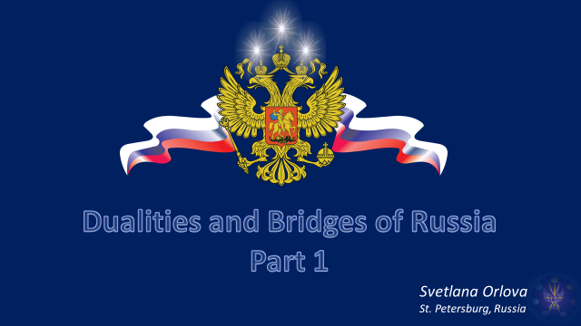

Dear friends, I don't speak English well, so I asked Uta to read my talk.
Thank you kindly, Uta!
But, some phrases (фрэйзис) I will try to say myself, creating a sound bridge between us.
I will tell you about Russia.
I will try to add some color to her image, to highlight some historical moments, and to look inside her psychological life.
Of course, I will reflect on the forces and energies and make some assumptions in this regard.

But first, a little introduction.

Two of Tibetan's statements:
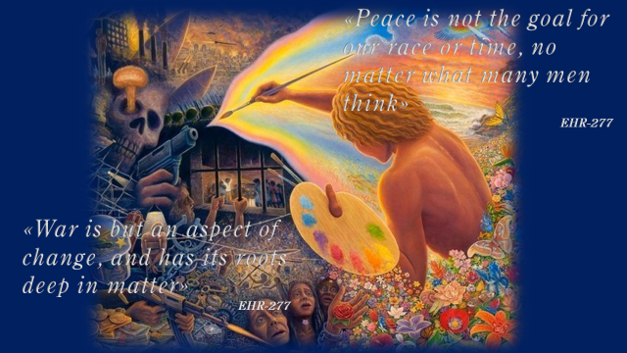
First: "Peace is not the goal of our race and our time".
This is obvious to every disciple for whom peace means complete control of soul over form, spirit over matter. Until then, it is war. A war with one's lower qualities, a war to integrate and purify the vehicles of the soul, a war with glamour and illusion.
And as humanity is still passing through the threshold of the first initiation, (or maybe has already passed) the real war for it is just beginning. Humanity will now more clearly distinguish the pairs of opposites of its own nature and gain greater sensitivity to the kaleidoscope of forces and energies affecting it.
Second: "War (уо) is only an aspect of change; it is deeply rooted in matter itself».
Slide
So as we look at people, nations or national conglomerates, we must understand that these are only temporary forms of some global energy processes in the body of humanity. Each nation has its own long-standing grievances, karmic trails, special energy lines. They stretch from the deep past, and are sometimes not obvious in the current incarnation of the nation.
The Tibetan also draws our attention to the fact that the history of Christianity is the history of Europe, which is defined by the abuse of the Law of Attraction and Repulsion that has produced various cleavages. And the entering Seventh Ray will bring healing and affirm synthesis.
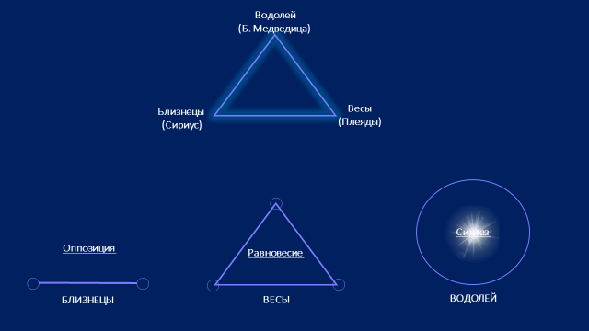
Let me remind you, that the Way from dualities to synthesis, is ruled by the Air Trigon, the channel for the energies of the Great Constellations.
Slide
Its work leads all pairs of opposites - from the recognized opposition of Gemini, through the balance point of Libra - to the synthesis of Aquarius.
This is especially relevant, given that the now steadily increasing influence of Aquarius is the soul sign of both Russia and America, who represent the most acute pair of opposites of the current crisis. If you add to this the fact that humanity itself, still standing at the point of Libra, trying to find the golden mean between the already recognized spiritual ideals and the pleasures of material diversity, the depth of the current world crisis becomes clear.
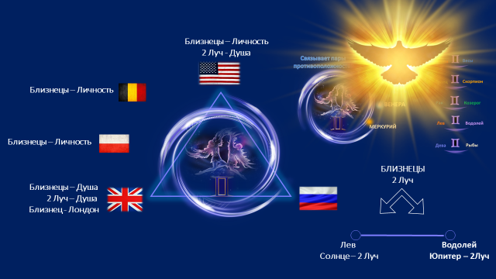
The energy of Gemini is well manifested in the key triangle of nations, and in Europe itself, too, creating a kind of bridge:
Slide
We have the US, the UK, Brussels as a focal point of US influence in Europe, and Poland as a faithful representative of American and British influence, not forgetting of course its own interests.
And then the bridge stops at the huge space of Russia; and somewhere between Warsaw and Moscow lies the dividing line between East and West.
Slide
Of course, it is obvious that the energy of Gemini rules the Leo-Aquarius pair of Russia, as the third apex of all opposite signs of the Zodiac, encouraging them to synthesize through the power of the Second Ray, which enters through this sign into the solar system.
This energy can heal the rifts the opposition has created.
Perhaps this process will be accelerated when the mind of humanity is ruled by the 4th Ray and the "law of loving understanding." Gemini will then conduct the light of the intuition, a sense of group coherence capable of overcoming any contradictions. I would like to believe that after 2025, when the 4th Ray's influence begins to increase, we will see this trend more clearly..

Now, after a brief introduction, let's look at Russia.

In Russia, whose Personality, and most likely also astral body, is ruled by the 6th Ray, and whose dominant religion is also on the 6th Ray, the problem of cleavages is pronounced.
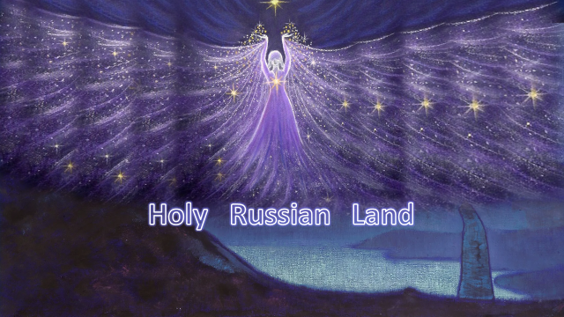
History shows that from the beginning of the 14th century the soul of Russia began to appropriate its physical vehicle, organizing human and deva units of a certain quality, seeding with them the appropriate territory.
And then arose the concept of the "Holy Land of Russia". New territories were settled in an interesting way. A monk would go into the deep woods and set up a hermitage and pray there. People would come to him from afar for advice and blessing. Some stayed and built houses nearby to pray and live a righteous life together. That's how villages arose, that's how Russia grew in land.
The focal point of this process was Sergiy Radonezhsky. He proclaimed the spiritual foundations of community life in a way which could be understood by everyone.
Slide
Nikolay Roerich dedicated his paintings to Saint Sergius.
Elena Roerich called him, quote: "the great Teacher and Guardian of Russia, who saturated the spirit of the people with fiery grace and high ideals that defined the nation's genetic code».
What is this energy? Can we see its earlier manifestation in the Age of Pisces?
I think it is that line of the first aspect of the sixth ray energy of Christianity, which comes from the Apostle Peter, who established his communities in modern Syria, Iraq, Iran, Turkey, Central and Northern Asia, the Caucasus, and even in China.
May this energy line not be the basis of Russia's close friendship with these countries?
Then Peter founded the apostolic "Church of the East," with its simplicity, purity, and depth of righteousness of community life.
Slide
For Russia, whose physical body apparently vibrates on the first ray, this branch of Christianity was very consonant and became a force linking people and territory into a single state formation.
This process was formalized under Tsar Ivan the Third, by the middle of the 15th century, when the newly born Russia declared itself as an integral state with state borders, a formalized life center - its capital Moscow, a set of laws regulating its inner life, its own state symbols and a central point of consciousness in the person of the sovereign, who proclaimed to the world "I am the Tsar of All Russia".
And if anyone would like to delve deeper into the spiritual ideals of the Russian people, meditate on Peter's first council message and his words: "Finally, be ye all of one mind, compassionate, brotherly, merciful, friendly, humble" (Chapter 3:8)

Friends, you will probably say, that this is not like Russia.
Remember, the Tibetan pointed out, that the qualities of her energies are the most humanistic (хьюманистик), harmless and leading to Brotherhood.

And Fraternity, as we remember, is the synthesis of all life on Earth in the consciousness of God Himself. And the manifestation of such Fraternity through the fusion of all pairs of opposites is the culmination of the Gemini work.
Russia has sought for centuries to realize these principles. It has emphasized Jesus as the perfect but earthly man and Christ as the higher principle that brings forth the Will of God. And the task of man is to become such a pure channel for God, through a righteous, holy, community life, in works and prayer. And this can only be achieved, as they say in Russia, «with all the world».
Repentance was seen as an internal process of alignment, of contact with God as a Teacher. No priestly mediation of absolution was required. The church was only a home for conjoint prayer, an inner work in a unified group channel.
I think it was this vision that could lead to the doctrine of reincarnation, the denial of which has become a black mark for the modern Christian church with its indulgences, luxuries, and political ambitions.
It is important for us to understand that the current war in Ukraine has deep esoteric and religious roots. It is, among other things, a war of the modern church form of Christianity, with those powerful energies that are hidden in the depths of the religious spirit of the Russian people. They are capable of destroying this crystallized, corrupt and politicized modern church. And this degraded but still powerful form is very much afraid of it.
Therefore, under the cover of military action, in Ukraine there is a process of the eradication of everything Russian, the destruction of the Orthodox faith and the destruction of its churches and monasteries.

You may ask - why exactly is Ukraine a battlefield?
Perhaps, this territory is an energy channel (at the level of the solar plexus), through which Russia is connected to the world astral sphere and its religious life.
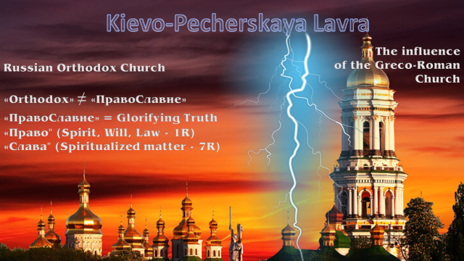
It was from the territory of Ukraine to Russia began to penetrate alien to Russian Orthodoxy symbols and rituals of the Greco-Roman model. The slide shows the deeper meaning of the Russian word "Pravoslaviye.
Interestingly, Kievo-Pechorskaya Lavra, the great shrine of Orthodoxy, is historically divided into two parts: the lower (or inner) part, the monastic, sacred, cave-like part, and the upper (outer) part, the majestic, celebrated beauty of architectural forms.
So, by 1650 in Russia, the conflict of the two forces is formalized and two personified focal points in the astral body of the Russian nation emerge:
Slide
Patriarch Nikon and Protopopop Avvakum.
And the apogee of their religious confrontation in Moscow goes hand in hand with the war between Russia and Poland on the physical plane for control of the Ukrainian lands.
As a result, Ukraine joins Russia as a very wide autonomy. And in Russia there is a grandiose church split, in the process of which all the vices of the Sixth Ray come to the surface - fanaticism, commitment to its own ideals, as well as uncompromising in the ritual form.
Slide
The focus of the nation's personal life shifted to the astral plane and literally inflamed its solar plexus center. This fire had its expression on the physical plane as well. The Western influence was stronger, and within 140 years the monastic cloisters across Russia were in flames - in them they burned alive those who adhered to the native Russian form of divine service. Their rights were not officially restored until 2000.
So, in the crucible of church dissent where more than 200 thousand people have been burnt, the Russian people also has been split. The Church, in the person of Nikon tried to stand at the head of the state, and to establish in Russia the universal throne of Orthodoxy and absolute theocracy. This, most likely, was already the influence of the seventh sub-ray, which in Europe led in 1860 to the question of the infallibility of the Pope.
Russia is still extremely sensitive to everything that comes through Kiev. Jolts through the solar plexus, which becomes an open gateway at a certain point in the aspirant's life, are very painful and can provoke an acute reaction. The historical memory of battles over territory and battles over symbols of faith, is very strong in the people.
Through the gates of Ukraine even today penetrates what Russia has been fighting against for centuries. This time quite infernal forces are entering through these gates, and Orthodox churches are burning again... Denis will touch on this a bit in the second part of his talk.

Going back to Peter's apostolic line, it may be recalled that the struggle against evil, primarily in himself, was key for him. Apparently, it is a key theme for Russia as well.
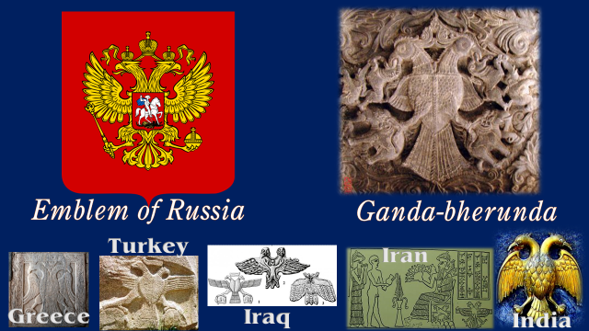

At the heart of the emblem of Russia lives a rider on a white horse, destroying the forces of evil (ивэл) with a spear.
The spear, like the sword, is a symbol of the First Ray, and Archangel Michael, one of the main tutelary saints of Russia, is the exponent of this energy, which, as we know, engages for its descent into the three worlds the Seventh Ray.
Slide
And the very symbolism of the double-headed eagle, extends a thread to the Indian Vedas and the ancient religions of Asia. Isn't this energy the basis of the current cooperation of these countries?
Ganda-bherunda (which translates as strong-terrible) is not only a symbol of duality, but also of vahana, the mighty fiery energy of Maha-Vishnu himself, which is released when the world is filled with evil and which even Shiva himself, with difficulty, manages to tame. It is also a solar symbol, and the two heads of the eagle show the two points of the solstice, summer and winter, light and darkness, soul and personality. God Savitar, sung by the Rig Veda, is called an eagle, and in incarnation manifests as two eagles sitting on the tree of life, the symbol of the duality of the soul.
Russia today has entered the battle with Evil, because the rich flowering of materialism is Evil for the spiritual essence of Russia, wherever it is located - inside its personality or outside.

Interestingly, in the 21st century its tool becomes a religiously nurtured spirit of patriotism as loyalty to the Fatherland, as an expression of the observance of the commandments of the Heavenly Father and a readiness to destroy what does not conform to them.
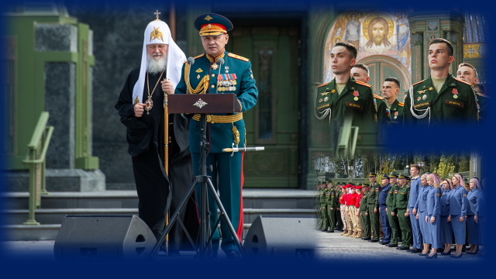
Here we see, today, the point of unity of the two branches of Christianity, and the point of integration for the Russian people.
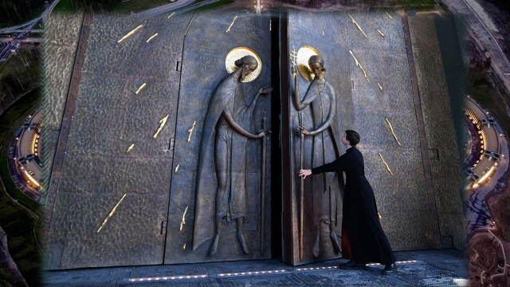
This is also expressed in its external form. For the 75th anniversary of the victory over fascism, near Moscow, the Temple of the Armed Forces of Russia was erected. It is filled with unusual symbolism of colors and materials. It is made of glass and metal melted down from Nazi weapons from World War II. It also contains symbols of both branches of Orthodoxy.
Try to capture the stark beauty of this Temple and the energy behind it.
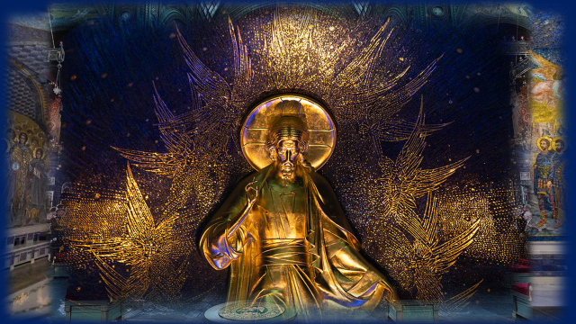
(Pause until the end of slides)

So, let's see the overall picture, to better realize the energy state of Russia.

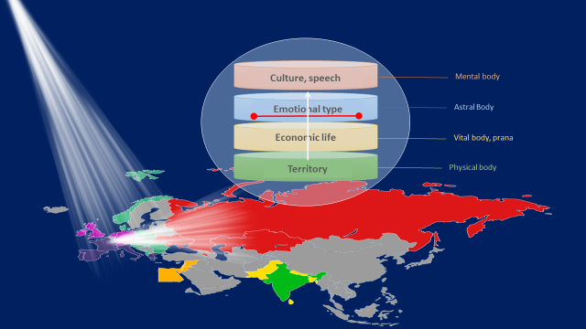
By the beginning of the 18th century, Russia, as a nation, had formed its physical and astral vehicles and experienced a cleavage within the emotional body. Pushing back from the two poles that emerged, her consciousness rushed toward the mental plane to form a center of control over her astral nature.
Slide
This was facilitated by the heyday of the Enlightenment in Europe. Since this period, the relationship between Russia and the West acquires a new dimension. Previously, the relationship was at the level of physical-etheric and astral vehicles, which was expressed in territorial disputes (or alliances), trade relations and religious influences.
Slide
Now Russia is turning to Europe as the source that brings the light of knowledge.
We are told that the method of the Seventh Ray, the method of the New Age, will no longer be related to the duality of the astral plane, where Arjuna fought in the past and where the religious life of the mystic is focused. For the disciples, including the nations, the two poles will be the focal point on the mental plane and on the physical plane.
Slide
And a clear direct channel must be created between them. Perhaps this is what the Tibetan meant when he spoke of Russia as Arjuna in a "very specific sense"?
The holiness of the earth, the purity of the motive, is the condition for the manifestation of the soul of Russia. The Seventh Ray, the ruler of the etheric plane, always seeks its point of polarization in the material world, linking the pair of opposites - spirit and matter.
Now the mystical Russia is faced with the task of forming a center on the mental plane, through which the energies of the soul could flow. The city of St. Petersburg, founded by Peter the Great in 1703, becomes the outward expression of such a center.
A second capital emerges, and a new duality within national life.

But, I will talk about this, in the second part of my presentation, on the final day of the conference.
And now, please watch a little video. I made it, as a starter for our webinars on the Full Moon in Virgo.
I used paintings by Nicholay Roerich, and some of my own sketches, to create the video.
Singing - monks of the monastery.
The two inscriptions in Russian - are the final two lines of the Great Invocation.

Thanks, friends, for your attention!

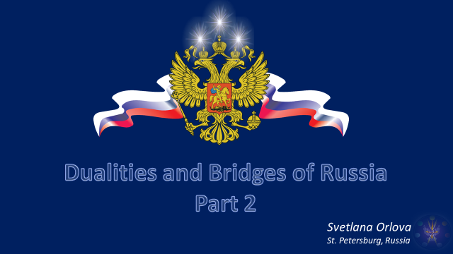

In the second part of my talk, we will continue to explore the history of Russia, its key moments.
We will look in more detail at the quality of Russia's two capitals. Then, we will try to recognize Russia's present state, and understand its future aspirations.
I am supported again today by Uta.
She also helped me edit the English text. Thank you, Uta, for this amazing collaboration - the bridge between East and West is made up of many little channels of joint creative service.
Now, Uta, I give the talk to you!

In the 18th and 19th centuries, Russia was rapidly mastering the mental plane, building universities, developing science, industry, and incorporating new ethnicities and cultures into its national sphere. And also: concludes dynastic marriages and forms military alliances with Europe, wages wars and carries out cardinal reforms of all its national life.
The Russian navy is exploring the world, conquering Antarctica. Geniuses are born in Russia - Pushkin, Mendeleev, Tchaikovsky, Tolstoy, Dostoyevsky, Vernadsky, and many others. At the same time, the whole body of the nation is put under great strain - there are riots and an increasing rift between the poor and the rich.
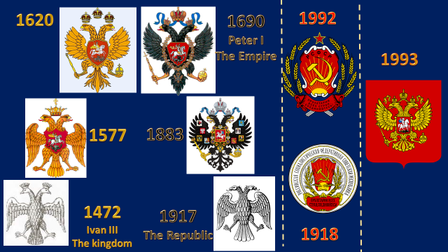
Look, by the way, at how the emblem of Russia highlights this period by changing the gold color to the black colors of the Western dynasties. Monarchical authoritarianism emphasizes the shadow side of the solar symbol, the dominance of personal life and the rational mind.
So, Russia by force coordinates its personality vehicles and becomes an empire. The activity of her mind and its vibrations are high enough to attract the gaze of the soul.

By this time, the influence of the 7th Ray is increasing. And we get a picture like this:

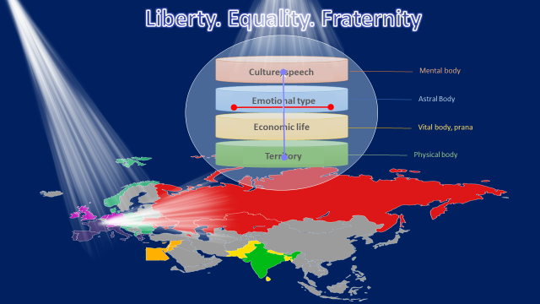
Russia, because of the deep ideal of community life inherent in its people, becomes very receptive to the ideas of the French Revolution and its spiritual seed expressed in the words "Liberty. Equality. Fraternity."
The best minds in Russia, become freethinkers, Decembrists, precipitating revolutionary ideas into the people. These minds become the center through which there is an alignment with the soul of the nation and the revolutionary force of Uranus. As a result, a direct channel is built up from the soul of the nation to the physical plane. It literally sets the masses of the people on fire. Lenin, by the power of his genius focuses and directs this energy, and sweeps away the monarchical form of imperial Russia. All of this happens brutally and bloodily, because it is the destructive aspect of the first ray, focused into the still darkened minds of the masses of Russia.
Therefore, the greatest contribution of the Soviet period which follows will be the universal education and cultural upbringing of the Russian people - from top to bottom.

And now we can recall another duality of Russia, expressed by its motto:

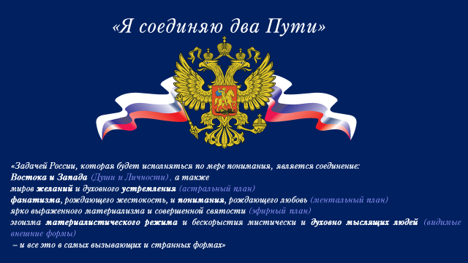
"I link two Ways." Which "ways" are we talking about?

The Tibetan gave us a hint, in the form of the following quote:
«Their task, which will develop as they come to truer understanding, is the linking of the East and of the West, and also of the worlds of desire and of spiritual aspiration of the fanaticism which produces cruelty and the understanding which produces love of a developed materialism and a perfected holiness
of the selfishness of a materialistic regime and the unselfishness of a mystically and spiritually minded people – and all this in a most pronounced and peculiar manner» DN, 61

We see clearly marked pairs of opposites, and they are present in every personality vehicle, top to bottom. Russia's soul energy creates these points of crisis in her personality, which is prone to split.
As the Tibetan said of Soviet-era Russia, there was, quote: "...the tremendous conflict which is going on between the fanatical sixth ray cruelty of her sixth ray regime and the spiritual harmlessness which is the basic principle of the national ideology" (The Destiny of Nations, 60).
And the main Russian sin of that period was the sin of isolation, or the closedness of her mind. This is eradicated today.
Friends, I want to draw your attention to the fact that everything the Tibetan said about Russia related to the period before 1949. That was the reign of Stalin, a mighty brutal personality who gathered the Russian people into a fist capable of resisting and defeating Nazi Germany.
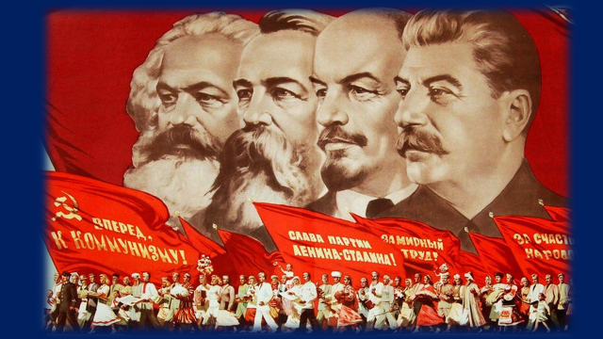

But then, there was another forty years of Soviet construction, when:

- the inner life of the nation was focused on educating society and building the material order.
- high ideals were detached from the masses of the people and died in party formalism.
- Russia's personal ambitions have expanded, and as a result it has created its own world political pole that opposes the West. This brought the world to the brink of disaster during the Cuban Missile Crisis.
Russia's Leo personality drove itself into a cave of self-isolation and spiritual exhaustion, which led to the crisis of the nineties and the collapse of the thought-form of the USSR.

Nevertheless, it was Russia's first spiritual project as a disciple. It gained a tremendous amount of experience of inner construction. Religious life was temporarily rejected and the task of educating the mystically inclined masses of the people came to the fore.

The pole of the mind, was to balance the pole of the heart.
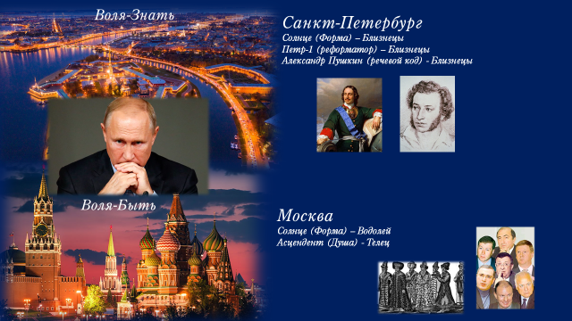
And the symbol of this alignment within Russia is the attitude of its two capitals - Moscow and St. Petersburg.
It is obvious that Moscow is the heart center, the source of vital energy of the state form of the peoples of Russia. Somewhere through the Nizhny Novgorod-Kiev axis goes the diaphragm area. And in the more southern regions the activity of the solar plexus and the emotional life of Russia is concentrated.
Slide
The influence of Taurus leads the capital by way of transmutation of lower desires. They have always flourished in Moscow, reputed to be a merchant city prone to wealth, avarice, pomposity and arrogance.

In fact, Moscow is the crucible in which the distillation, purification of the emotional life of Russia and the materialistic desires of its personality took place. The capital's personality sign, Aquarius, is still manifesting the lower qualities of Uranus. Moscow has a tendency toward formalism, bureaucracy, and the glorification of its own formal nature. All this absorbs the vitality of Russia, and also suggests that the heart center of Russia is still ruled by the proud Sun, rather than the generous Jupiter. Although some positive trends are already visible.

What is interesting, in the history of Moscow, its agent of internal disturbance and destruction are the forces that combine the qualities of the earthly Taurus, and the septenary nature of Aquarius. Even historically, the prefix "seven" has been used to refer to troubled times: the "Seven Boyars" of the early 17th century and the "Seven Bankers" of the late 20th.
Slide
This is a manifestation of the as yet unpurified energies that are overpowering Russia's first major center, its Eastern Capital.

Russia's second main city is the center of its mental life, and the focal point of the soul's consciousness (каншизнес) in form.

I correlate it with St. Petersburg, which, together with the cities surrounding it (Veliky Novgorod, Lomonosov, Pushkin), performs the function of the head and throat centers. The Western capital is a city with a pronounced Gemini energy.
Slide
Its founder, Peter the Great was born with the sun in Gemini, the city itself is founded in Gemini and many brilliant thinkers whose destinies are associated with this city – are also born in Gemini. For example, the expressive voice of the Russian soul - Alexander Pushkin.
This city arose as a response to the wave of light of knowledge that came from the West, awakening the activity of the Russian mind. Peter recognized this wave and, as they say, "opened a window to Europe. For 200 years, St. Petersburg became the capital of Russia, forming the focal point of its personality and attracting the gaze of the soul.

The energy of the soul, always brings about confusion, a fermentation, changes and crises (крайзис) in the personality nature, that of the person, and that of the nation.

Such stimulation made St. Petersburg the city of three revolutions, the center of secret societies and freethinking circles. Freemasonry, blessed with Gemini, spiritualism, expressing the energies of the seventh ray of Russia's soul - all this originated and flourished in this, the second capital.

This pair of cities, whose vibrations are sometimes vividly opposed to each other, can be correlated with the East (Moscow) and the West (St. Petersburg). One center should express the Will-Knowledge, the Way of the Mind, as a mediator for soul consciousness and a bridge for group relations of Russia The second shows the Way of the Heart, the Will to Be, and the will to establish the power of the soul on the physical plane. This is expressed in the imperial greatness of Russia, its ability to fuse many nations within itself, while safeguarding their identity and life goals.
Slide
A proper rhythm must be established between these two center-cities, a bridge must be woven, similar to when, at a certain evolutionary stage, a link arises between the main Heart Center and the Heart Center within the Head Center. Then a person, or a nation, acquires the ability to think with the heart, that is, to express the soul and serve the world, which is what Aquarius calls Russia to do.

Rhythm, ritual, is the most important component for Gemini (Джеминай), the rulers of the mutable (мьютебал) cross, which represents all energies, except the Seventh Ray...

The six-pointed star has a focal point in the center, the axis of willed energy, through which there is vertical movement by balancing and organizing all other six energies. Isn't this the task of Masonic rituals?
The West and its leaders, the U.S. and Britain, desperately need this energy... And it is Russia that can be its Source. Therefore, the desire of the West to zero out Russia leads them to chaos and slow down evolutionary processes, as we are witnessing now.

So, two capitals, two etheric centers - are the two focal points of the soul of Russia.
And in the historical past, we see that the focus of consciousness of the Russian people fluctuated between these two centers: sometimes there was a period of rational - merchant Moscow dominance, and sometimes the capital was mental and mystical St. Petersburg.

It is interesting that Putin, was born and established as a person and as a "Westerner" in St. Petersburg, and then became the head of the reviving empire in Moscow. With his advent Russia has a favorable opportunity to come into recognition of the role of the two centers, and to make an alignment between them and establish the right rhythm.

The Russian President has a very strong Libra influence. In this sign, in addition to the Sun, he has four other planets. And as we remember, it is Libra that rules the next stage, after the opposition, or discernment of dualities in Gemini. In Libra, the balance of the two poles is achieved. The opposing energies are then transmuted, harmonizing and rising to the point of fusion. Uranus, the ruler of Russian soul energy, as well as the esoteric ruler of Libra, is the source of the balanced energy so necessary for Gemini.
Slide
And Putin, as the focal point of the people of Russia, is a master of balancing. In these extremely tense times, he is leading the country to the internal state where it can give the world - both West and East - the necessary position of dynamic equilibrium and the establishing of right interactions.

Russia's craving (крейвин) for the West, so evident (эвидент) after the destruction of the USSR, is only the compensation of the insularity of its mind.
During the Soviet period of her reclusion, she was in search of some model that would express the idea of sobornost, of brotherhood, so precious to her soul.
Then, Russia again opened wide its window to Europe and prepared to give back all the most valuable things it had accumulated during the period of its isolation from the Western world. And, by the way, such a dramatic change in Russia's destiny also occurred under the sign of Gemini - June 12, 1990, when the old communist form was repudiated, although the new one had not yet been recognized. Again the energy of this Sign initiated the necessary, albeit heavy, changes, bringing Russia out of stagnation, and crystallization.

Russia's main problem (in the current historical period) is the consequence of her blind, fanatical devotion to an ideal, sometimes driving her almost to self-destruction. This, of course, is the 6th Ray quality of her personality. And also the ability to perform a total restructuring of her national form in favor of this ideal, grounding it and taking her condition to extremes. This is facilitated by the 7th Ray of the soul.
In the last century, Russia was inspired by the European ideal of " Liberty. Equality. Fraternity," which was consonant with its soul, but which it could not realize without distortion. To achieve this, the purity of the ideas imprinted in the ideal had to be supported by a stable connection to the soul, which was not yet the case. The result - the crystallization of the built form of the USSR and its collapse.
Then, after the external failure of its "spiritual project", Russia had a natural phase of denial of itself and its history ... despondency and a lack of vision for the future.
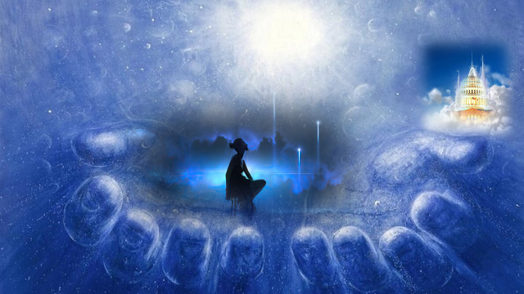
It was a crisis (крайсис), that could give Russia an opportunity to listen to its soul, to go through the pain and find new spiritual reference points.
But the desires for material goods suppressed during the Soviet period and the admirable ideal of the Western way of life opened to the eye, embellished by the six-rayed nature of Russia and beautifully presented by the West under the guise of "perestroika" - seduced Russia.
She has fallen "into the arms of the West," in the words of the title of a book written by Denis. And has given her whole self to a sect called "American lifestyle", created by the USA - whose national personality is also on the 6th Ray, and whose penchant for messianism is prompted by her soul on the Love-Wisdom Ray.
Please see, I will give some analogies.
As in any totalitarian sect, newcomers are required to:
- Complete obedience to the sect's rules (loss of sovereignty)
- Transfer of their property, personal potential and energy to the sect (plundering of the country, loss of financial and technological independence)
- Blind faith in all the socalled "ideals" of the sect (neo-liberal ideology)
- A ban on any other beliefs and one's own ideas about the truth (the constitution of Russia, which was modeled on the West, has a clause banning one's own ideology).
- Unquestioning оbedient obedience to the head of the sect and the powers that support him (the United States and the world behind the scenes).

And Russia itself has agreed to all this. Its fervent devotion to Western ideals, drove it to self-destruction.

In doing so, it has received the invasion of all the attendant ills that thrive in the sect - corruption, oligarchic lawlessness, corporate power, the glamour of transhumanism, LGBT perversion, etc.
Slaid
But it is precisely because of the situation in Donbass: the genocide of Russians, the atrocities, the destruction of cities, the burning of churches, the open hatred of the West and contempt for our legitimate requests that the people of Russia began to wake up and realize the abyss into which they are heading.
For eight years (since 2014), the resilience of the people of Donbass has gradually inflamed Russia. Standing up for the weak and oppressed is the deep essence of the Russian people. Not to stand for oneself - for one's brother, for justice, for the truth, for God! This is a deeper and stronger ideal, formed in the centuries-old history of the Orthodox country. It has risen to the surface and caused a split within the national consciousness. After all, for many, the sect has already become home, the only way of life, and it's not easy to get rid of the morass.
Slide
But today Russia is leaving the totalitarian sect of the West. It finds itself quite robbed, disappointed in its former ideals, having lost its old friends and slightly rotten morally.
But in the pantry of the soul of the Russian people are stored priceless gifts of her life experience: the sanctity of the Russian land, the purity and righteousness of community life, the unity of the soul, preserved in the heart of the nation and the bright genius of the Russian mind. All this will now be revived in the crucible of the battle for the right to be and express the fiery essence of Russia.
If the collective West can cope with its own glamour and hatred of Russia. If it sees behind all the dualities, contradictions and ray imperfections of the external form of this country, then it may recognize the life of its brother disciple, fighting for the soul.
You can also see that for Russia, the bridge between East and West - is the bridge between her soul and personality, the mental plane and the etheric plane, Leo and Aquarius.
This is the stage in the life of the disciple, that the Tibetan said:
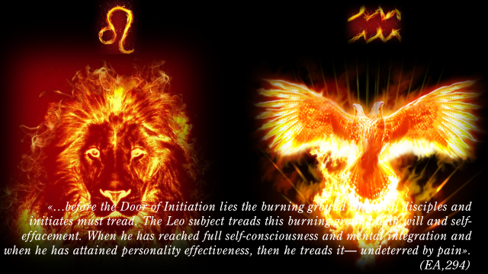

«…before the Door of Initiation lies the burning ground which all disciples and initiates must tread.
The Leo subject treads this burning ground with will and self-effacement. When he has reached full self-consciousness and mental integration and when he has attained personality effectiveness, then he treads it— undeterred by pain». (EA,294)

And it is Russia's voluntary Fiery Path as a disciple, along which she walks without fear of pain.

If the West realizes the healing power of its own soul on the Second Ray and shows an intuitive, group sensitivity to the soul feat of its brother.
Then new bridges will be built between the West and the East and European, as well as Eurasian, Euro-American and Euro-African unity will be able to be realized on the level of the souls of nations. And their mutual regard and cherishing of the special dharma of each nation will be the basis of their personality relations.
And there is no doubt, that this will be the case, for:
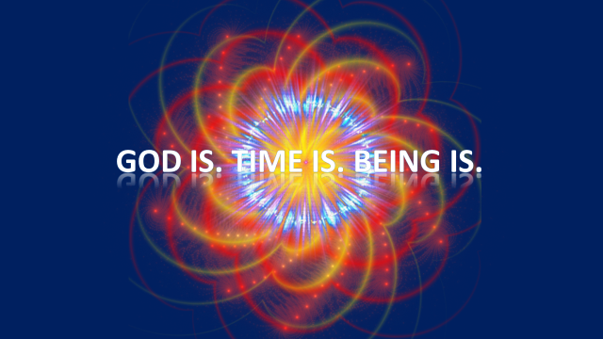

Thanks, friends, for your attention!
Thanks, Uta!
Thanks to all, who prepared this conference!
I think, you now have a better sense of Russia.
And at the end of my talk, please watch a clip of the Russian singer - Shaman. He perfectly expressed what is going on in Russia right now.

