GREECE AT THE CROSSROADS

I will explore Greece as part of Europe -and the European Union- and Europe’s relationship to Greece. All the while trying to focus more on the soul aspects of Greece and its evolutionary course during the ages and how the Country has been affected, in relation to personality aspects or form. Both intertwined and separated

I take into serious consideration the injunction given by the Tibetan that the occultist should start from the greater whole and the universal and then move to the particular and individual and not the other way round but that doesn’t mean that I’ll start from the solar system. Always very helpful to use in our thinking the great Law of Correspondences or Analogy/LOGOS.

We know of Union existing in the esoteric realms of the soul and nations are like individuals (of a collective kind) having soul and personality in their equipment. We explore this concept with regards to the European Union and recognize its essence rather than getting distracted by the many problems and dysfunctions of its outer expressions.
Diversity might be a better term to look upon than separativeness.

I’ll try to describe this journey from the past into the future through the present time taking into account that our “Western” civilisation is today at a crossroads, and at a turning point, just before a newer revitalization or regression. And, if possible, from the point of view of a world citizen to look at the transitory role of what we call homeland or nationality. Not absorbed too much in the past, not reaching out too far into the distant future but standing in the dynamic equilibrium of their meeting point – at the present.

Looking at middle points ---
There is a myth about Delphi – the ancient Greek sanctuary and oracle place of Apollo, the sun-god upon whose temple the famous inscription “Man know thyself” was written. It tells that Zeus in his attempt to locate the center of the earth has sent out from Mount Olympus two eagles in opposite directions; the two eagles, starting simultaneously and flying at equal speed, crossed their paths above the area of Delphi. This marked the center of the world and at this point it was where allegedly Zeus placed the stone of omphalos – the "navel of the Earth."

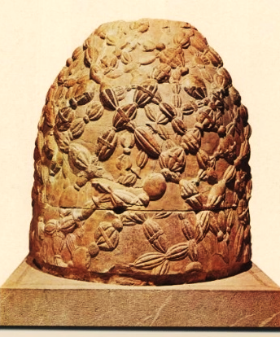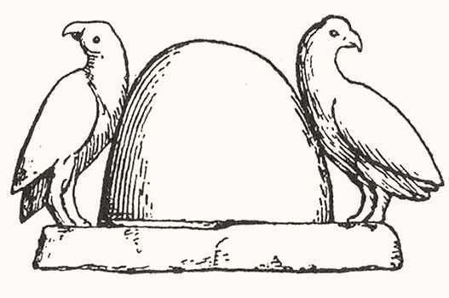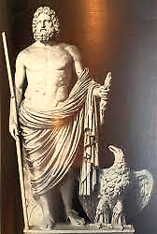

The omphalos (navel-stone), the symbol of Delphi.

Gaia was the Greek name for Earth and at this site an archaic veneration of the primeval mother goddess took place whilst not surprisingly the name Delphi, etymologically derives from the root (δελφύς) delphys, meaning “womb” (Virgo). In ancient Greeks’ concept of the world, continents were part of Gaia hence physical entities and offspring of gods and goddesses, Titans and Heroes relating supernatural and natural, heaven and earth, cosmos and man, rather than mere landmasses surrounded by waters and oceans. Greek mythology – Myth of Europe – and Hesiod’s Theogony reflect and hide these ancient truths.

In the Ancient Wisdom Teachings, we read of “The Life which expresses Itself through seven planetary centres, or continents” (EP I) and also that “in this fifth rootrace It is… with … five centres [out of the seven] that we are concerned.” (The Destiny of the Nations) These “externalisations which are called the five continents” (Europe, Africa, Asia, Australia, America) are said to be the product of “five signs … (Cancer, Leo, Scorpio, Capricorn, Pisces) related to the five great races - of which our present race, the Aryan, is the fifth. (EA)

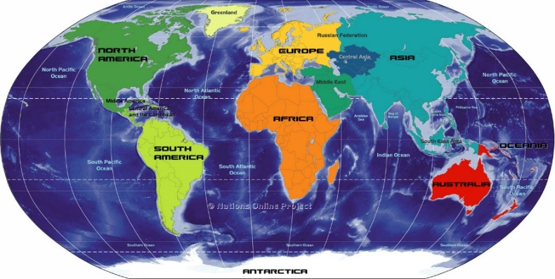

All these appearances, expressions of qualities and material evidences of life are the symbols or outer and visible signs of inner and spiritual realities. In this sense - “These five continents are to the planetary Life what five major endocrine glands are to the human being … related to five centres.” (EA) To be mentioned here, that “The word "endocrine" it may be noted is from the Greek word "krinein," meaning "to separate." (S&M)

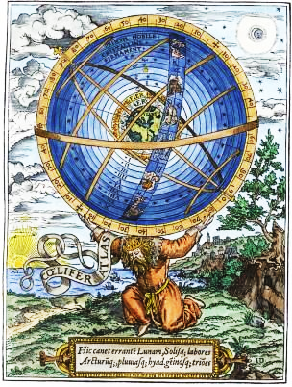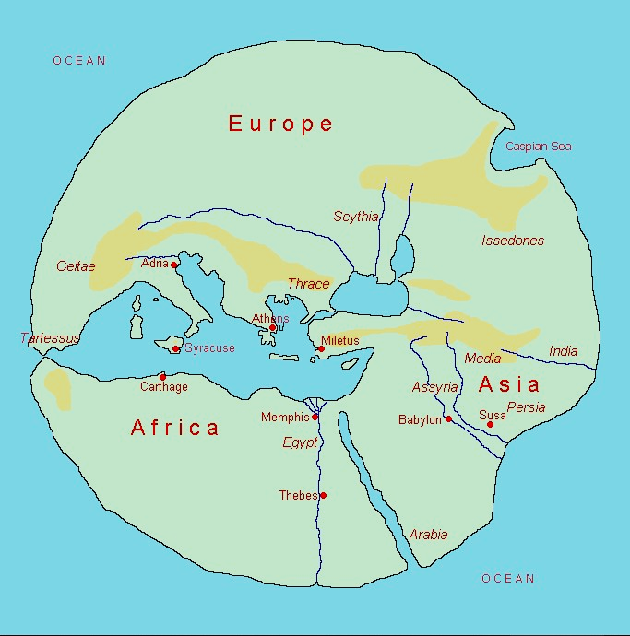
Reflecting the ancient Greek notion of a unitary human terrain, although, “in the old conception, Europe, Africa and Asia were usually envisioned as forming a single, interconnected “world island,” the Orbis Terrarum. Therein, Mediterranean Sea – a “child” of the great Atlantic Ocean, once the territory of the Titan Atlas, the Bearer of the Heavens – was according to its name pointing to “the middle of the earth” (μεσόγειος, μέση γη).

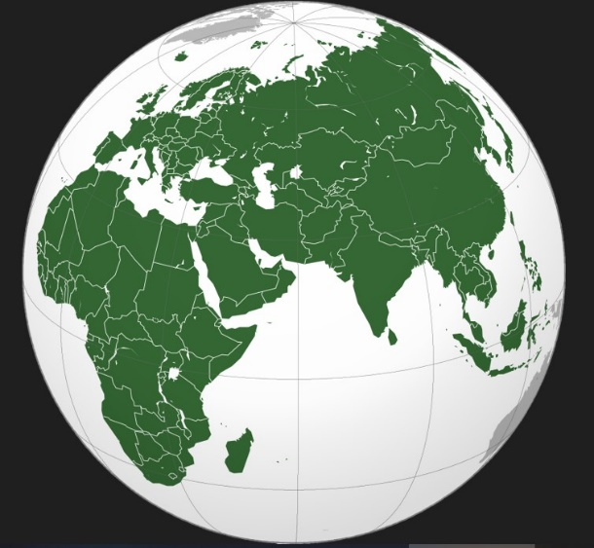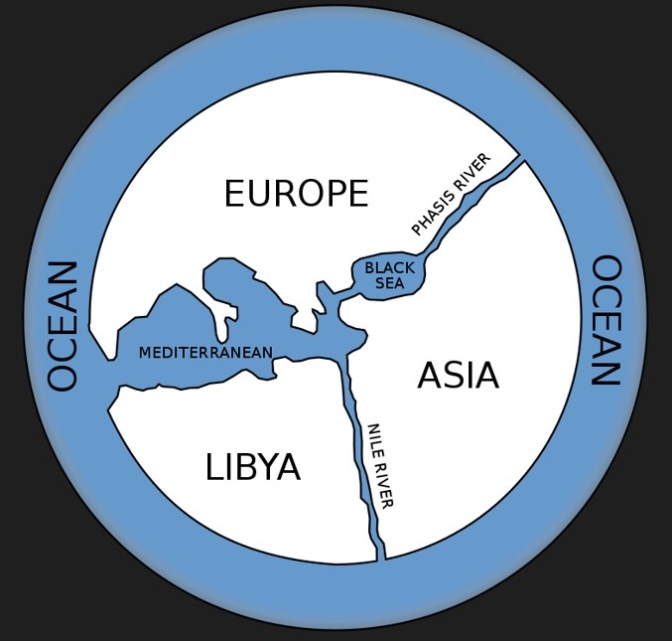

It was by the late nineteenth century that the old "parts of the earth" had been definitively named "continents," with the separation between Europe and Asia remaining central to the scheme. The Oxford English Dictionary (compiled in the decades bracketing the turn of the twentieth century) recounts the transition as follows:
"Formerly two continents were reckoned, the Old and the New; the former comprising Europe, Asia, and Africa, which form one continuous mass of land; the latter, North and South America, forming another.

A future development is presented to all disciples in Education in the New Age. It refers to “the three great continents – Asia, Europe and America – and to their contribution to a triple unfoldment, as far as the Aryan race is concerned. To this triplicity is given the analogy of “soul, mind and brain” and their analogy to man when they “will be functioning as they should and in right relation to each other, producing coordination and correct alignment”. (A man will then be instinctively correct, intellectually sound, and intuitively aware). Perhaps a distant image of the planetary antahkarana in the construction process implying also the idea of direction through two phrases known to many of us: of “the light which streams ever from the East” (DINA II) and also of “the tide of life [that] moves from East to West as moves the sun” (Glamour/180). "The sun was the image of divine intelligence or wisdom.... The word `sol' (sun) was derived from `solus,' the One or He alone, and the Greek name `Helios' meant Most High." (S.D. III. 279.) EA Let us also take into account that in the Teachings Light and Life are synonymous and interchangeable terms.

In this context to notice that the name Europe is attributed to the Phoenician word “ereb” [‘where the sun set’] and Asia from “asu” [the word for sunrise]. And, it was only from this central area of the ancient world where many civilisations developed, flourished and then declined that one could look at the part of the sky where the sun is rising - calling it Orient and to the other side of the setting sun, calling it Occident. Therefore, Ancient Greeks naturally did consider themselves and their land to be a “midway” or ‘navel’ of the world.

“As in the outer, so in the body; as in the body, so in the other” is an ancient axiom from the Buddhist’s Kalachakra teachings tradition which “emphasizes the similarities and correspondence between human beings (inner Kālacakra) and the cosmos (outer Kālacakra). Under this angle we may find significant the Tibetan’s words that “the Eastern and Western hemispheres function like the right and left lobes of man's brain” (…) and more specifically: “In one lobe the reasoning mind has its seat, whilst the other is responsible for the imaginative emotional faculties, and the power to visualise.” (S&M)

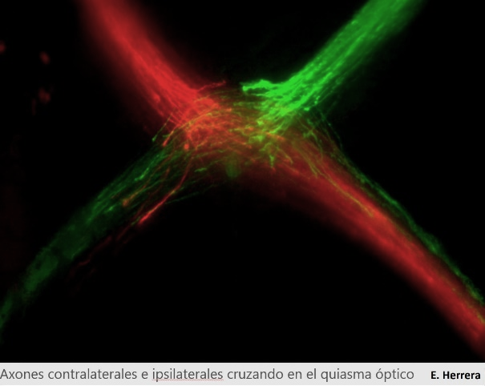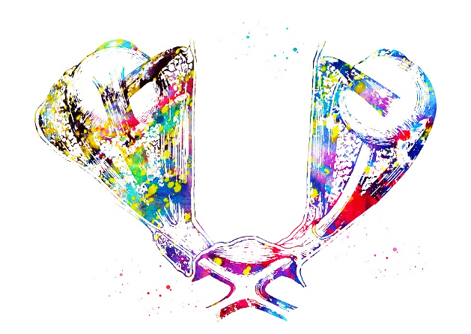

In addition, and confirmation of the above, “the seat of the World Brain serving as the point of decussation of the planetary nerves”. This image is of high symbolism bringing to our minds the picture of the optic nerve fibres, which after decussating at the optic chiasm, form the optic tract and are then divided into two bundles (pic on the right). And, looking closer we may recognize also the symbol of the cross taking shape. Chiasm is a Greek word (ΧΙΑΣΜΑ) with its first letter being a Chi-X (X=24/6) and it explains as crosswise or quincunx, possibly explaining the 5 points of X – the first letter of the name of Christ/XΡΙΣΤΟΣ.

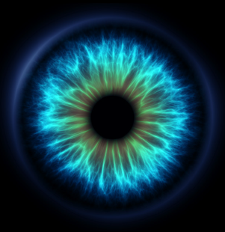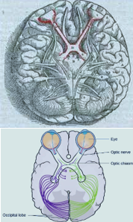

The significance of this marvelous structure – planetary and human – is portrayed in Esoteric Healing, where Master DK tells us: “One hint I can give you”, “the optic nerve is a symbol of the antahkarana, and the entire structure of the eye ball is one of the most beautiful symbols of the threefold deity and the threefold man”.

This unity in diversity is further elucidated in (LoM) “The orient is to the evolving race of men what the heart is to the human body; it is the source of light, of life, of heat, and of vitality. The occident is to the race what the brain or mental activity is to the body, —the directing organising factor, the instrument of the lower mind, the accumulator of facts.”

So, we might say that at their midway, meeting and cross-point of time a space – analog to a greater midday time – a unique spiritual event took place changing the course and giving a new impetus to our planetary evolution. It is precisely described in the book Bethlehem as follows: “… in that strange little country called the Holy Land, a narrow strip of territory between the two hemispheres, the East and the West, the Orient and the Occident, Christ mounted the Cross and fixed the boundary between the kingdom of God and the kingdoms of the world, between the world of men and the world of Spirit.” Taking His stand beside all the previous crucified Saviours Christ assumed the ancient symbol and burden of the cross embodying in Himself the immediate and the cosmic, the past and the future… Thus, He brought to a climax the ancient Mysteries, which had prophesied the coming of that kingdom, and instituted the Mysteries of the kingdom of God.”

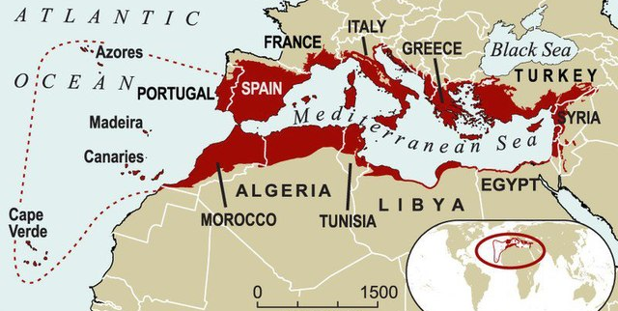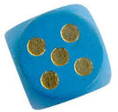

Connecting the five dots of the X or Cross we may find a clue in the vibrating center of their crossing lines of energy – a midway point. We are told that “The Master of all the Masters took incarnation in Palestine, that slice of land which is midway between Asia and Europe, and which partakes of the character of both.” Consequently, midway points can be seen as centers of dynamic activity and tension, fields or planes of transition and of temporary instability. Hence, they may indicate a crisis as the one indicated for the sign of Virgo – “the crisis of the birthplace”.

It is assumed that such a crisis took place in ancient Greece – with its rising sign in Virgo - initiating the “awakening of the intellect”, reason, logos and logical thinking and bringing as their fruit (condensed in only one, called, the “golden eon”) a bright culture of human achievement in sciences, arts and crafts, philosophy, politics and warfare, rhythm and beauty, ethics and law – to enumerate only a few. Not to forget that the thinking principle is the main characteristic of humanity – the "midway point," in the consciousness of the Creator. (WM) It shouldn’t be seen of minor importance that through the Greek language (logos), in wide use all over the known world, the message of Christianity and Christ’s teaching travelled through the Gospels and was spread relative rapidly westwards.

Resuming it might be said for our Western civilization that it flourished from the roots of the Oriental Wisdom and through the vital stem of the ancient Greek and later Roman civilization. Nevertheless, the spiritual realities of our world are still hidden from our eyes under a thick veil. Today the whole of humanity is at the crossroad between two greater time cycles: the Piscean era expiring and the dawning Aquarian Age. Yet their overlapping portrayed in a form of Vescica Pisces holds within it – as in a womb – the divine golden triangle, with Christ at its center/heart.

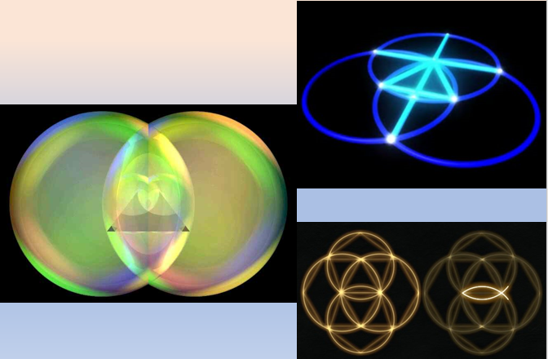

Coming back to “the three great continents – Asia, Europe and America – and to their contribution to a triple unfoldment, as far as the Aryan race is concerned (5th/3rd), we can realise in their correspondence to “soul, mind and brain” that the European continent stands “midway” – thus related to the mind nature, in which the antahkarana is anchored.

“Within the body of the planetary Logos humanity is slowly building that which they call the antahkarana; this is, in reality, the linking thread between the head centre of Sanat Kumara and His heart centre.”

The European Union -consisting of 27 Member States, known as European countries – may be characterized as the most critical and important European project of modern times. Based on European ideals, cooperation and partnership it’s not only for Europeans important, but also for the world. We may well assume that behind this group experiment stands the Hierarchy, its Masters and the Christ from his office as the “Unifier of East and West”.

Working today in this Conference and for the next 3 days in group formation with meditations, sharing reflections and in discussions let us sound forth the keynote of the soul of our nation – fused within the greater group soul as an integral part of the soul of Europe.

For Greece ruled by the sign of Virgo the keynote is “I am the mother and the child; I God, I matter am”; for the whole of humanity and the soul as the force of evolution let the keynote be sounded: “Christ in us, the hope of glory”.

